**Design Patterns and Principles:**

**Exercise 1: Implementing the Singleton Pattern**

**OUTPUT:**

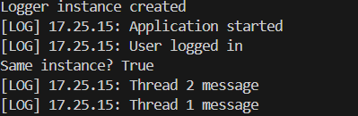

**Exercise 2: Implementing the Factory Method Pattern**

**OUTPUT:**

